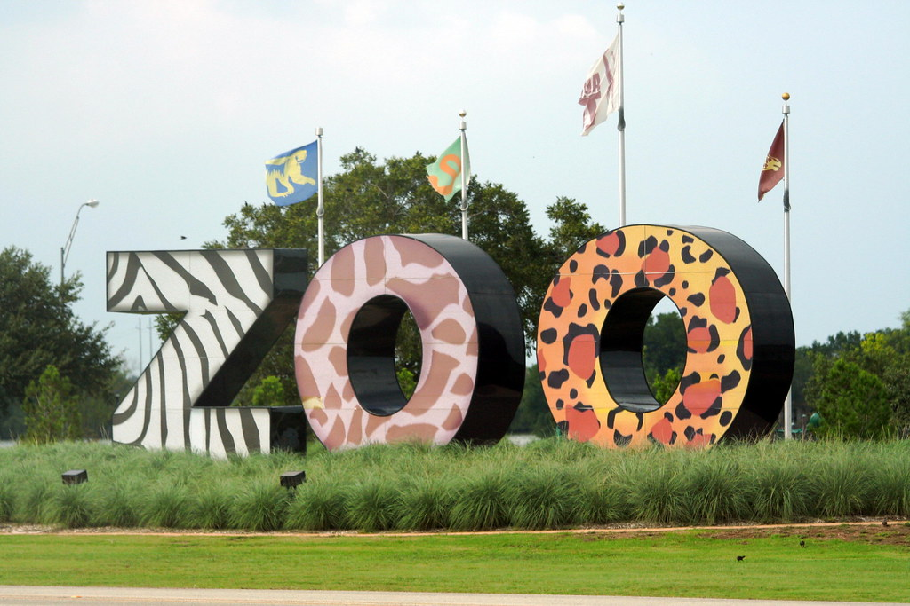
Mrs. Deal’s Zoo-News
December 16th, 2021

Headlines

Merry Christmas! I wish all of your families a joyous and Merry Christmas. May your break be filled with precious memories.

Art! Elementary classes will be participating in art on Fridays when we come back from Christmas Break. There are a few supplies they will need, and most can be purchased at the Dollar Store:
2 packs of paint brushes
Watercolor paint set
Markers
Glue stick

Field Trip! We have our all-school field trip coming up January 19th. It seems like a long time away, but it will come quickly. I am looking for a few parents to drive. If you are interested, please let me know. There is no “Sign Up Genius” for this event.
The cost will be $5 for students and $8 for adults. We are visiting The C.A.R.E. Foundation, which is a wild animal rescue and education facility in Apopka. Perfect for the 4th grade zoo!

Our next class book is The Mighty Miss Malone by Christopher Paul Curtis. If you could please get that for your student when we in January. I got it from Amazon for $7.99. Please have this when we return. The students will be reading in class as well as having at home reading and comprehension assignments.
It’s such a pleasure to read and experience books as a class!

Homework Schedule: Days due
Monday-Science and History
Tuesday-Spelling and Math
Thursday-Reading Comprehension

Next Week’s Homework

Monday, January 3rd
Christmas Break

Tuesday, January 4th
Back to School

Wednesday, January 5th

Thursday, January 6th
Report Cards come home

Friday, January 7th

Coming Up:
1/12 SGA Movie and PJ Day
1/17 No School, MLK Day
1/19 C.A.R.E. Field Trip
1/20 New Family Open House
1/25 Monthly Bible Activity and Verse due
2/2 Midterm ½ ReadNQuiz due
2/10 Elementary Progress reports
2/11 Valentine’s Day Parties
2/21 President’s Holiday
2/22 Monthly Verse and Bible Activity DUE

Spelling List
None this week
Vocabulary Word list
None this week

Due January 25th,
but can be said any time before then
Matthew 3:16
After He was baptized, Jesus came up immediately from the water; and behold, the heavens were opened, and he saw the Spirit of God descending as a dove and settling on Him

